**Ham Dashboard Instructions**

I have included my customized version for the Florida Keys of the the Dashboad. It is free for you to use and customize. It is now bug free.

**This is the presentation from VA3HDL on his dashboard:**

<https://www.youtube.com/watch?v=sIdqMQTGNSc&vl=en>

**The dashboard can be found at:**

<https://github.com/VA3HDL/hamdashboard>

**This is the config.js file from VA3HDL. The instructions for various items are embedded in it.:**

const topBarCenterText = `VA3HDL - FN04ga`;

// Grid layout

var layout_cols = 4;

var layout_rows = 3;

// Menu items

// Structure is as follows HTML Color code, Option, target URL, scaling 1=Original Size, side (optional, nothing is Left, "R" is Right)

// The values are [color code, menu text, target link, scale factor, side],

// add new lines following the structure for extra menu options. The comma at the end is important!

const aURL = [

["add10d", "BACK", "#", "1"],

["add10d", "BACK", "#", "1", "R"],

["ff9100", "Refresh", "#", "1"],

["0dd1a7", "Help", "#", "1"],

["2196F3", "CLUBLOG", "https://clublog.org/livestream/VA3HDL", "1.7"],

[

"2196F3",

"CONTEST",

"https://www.contestcalendar.com/fivewkcal.html",

"1",

],

["2196F3", "DX CLUSTER", "https://dxcluster.ha8tks.hu/map/", "1"],

[

"2196F3",

"LIGHTNING",

"https://map.blitzortung.org/#3.87/36.5/-89.41",

"1",

"R",

],

["2196F3", "PISTAR", "http://pi-star.local/", "1.2"],

[

"2196F3",

"RADAR",

"https://weather.gc.ca/?layers=alert,radar&center=43.39961001,-78.53212031&zoom=6&alertTableFilterProv=ON",

"1",

"R"

],

["2196F3", "TIME.IS", "https://time.is/", "1", "R"],

[

"2196F3",

"WEATHER",

"https://openweathermap.org/weathermap?basemap=map&cities=true&layer=temperature&lat=44.0157&lon=-79.4591&zoom=5",

"1",

"R",

],

[

"2196F3",

"WINDS",

"https://earth.nullschool.net/#current/wind/surface/level/orthographic=-78.79,44.09,3000",

"1",

"R",

],

];

// Dashboard items

// Structure is Title, Image Source URL

// [Title, Image Source URL],

// the comma at the end is important!

// You can't add more items because there are only 12 placeholders on the dashboard

// but you can replace the titles and the images with anything you want.

const aIMG = [

["RADAR", "https://radar.weather.gov/ridge/standard/CONUS_loop.gif"],

[

"LOCAL RADAR",

"https://radar.weather.gov/ridge/standard/KNQA_loop.gif",

],

[

"NOAA D-RAP",

"https://services.swpc.noaa.gov/images/animations/d-rap/global/d-rap/latest.png",

],

[

"ISS POSITION",

"https://www.heavens-above.com/orbitdisplay.aspx?icon=iss&width=600&height=300&mode=M&satid=25544",

],

[

"SATELLITE CAN",

"https://cdn.star.nesdis.noaa.gov/GOES16/GLM/SECTOR/can/EXTENT3/GOES16-CAN-EXTENT3-1125x560.gif",

],

[

"SATELLITE CGL",

"https://cdn.star.nesdis.noaa.gov/GOES16/GLM/SECTOR/cgl/EXTENT3/GOES16-CGL-EXTENT3-600x600.gif",

],

[

"LIGHTNING",

"https://images.lightningmaps.org/blitzortung/america/index.php?animation=usa",

],

[

"LIGHTNING LOCAL",

"https://www.blitzortung.org/en/Images/image_b_ny.png",

],

["YOUTUBE EXAMPLE", "iframe|https://www.youtube.com/embed/fzPFaXAV_2Y?autoplay=1&mute=1"],

[

"WEBSITE EXAMPLE",

"iframe|https://globe.adsbexchange.com/?airport=YYZ",

],

["VIDEO EXAMPLE", "https://himawari8.nict.go.jp/movie/720/20240611_pifd.mp4"],

["HF PROPAGATION",

"https://www.hamqsl.com/solar101vhf.php"],

];

// Image rotation intervals in milliseconds per tile - If the line below is commented, all tiles will be rotated every 30000 milliseconds (30s)

const tileDelay = [

11200,10000,11000,10100,

10200,10500,10300,10600,

30400,60700,60900,10800

];

**PDF Files:**

The Ham Dashboard has support for embedded PDFs. Like this:

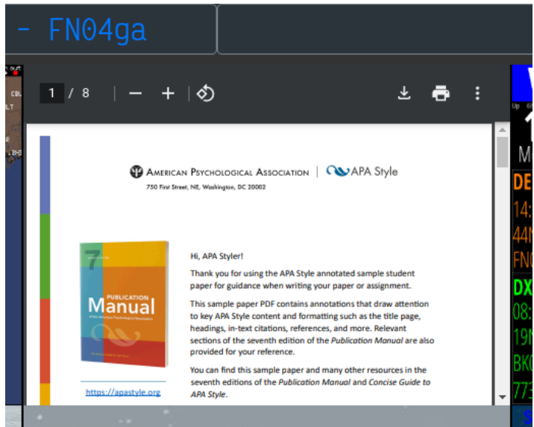

To show the PDF on a tile I've used this on the config.js file:

**"iframe|**[**https://apastyle.apa.org/style-grammar-guidelines/paper-format/student-annotated.pdf**](https://apastyle.apa.org/style-grammar-guidelines/paper-format/student-annotated.pdf)**"**

Alternatively, you can link the PDF via the left or right menu.

For local files you can place them in a folder called "PDF" for example:

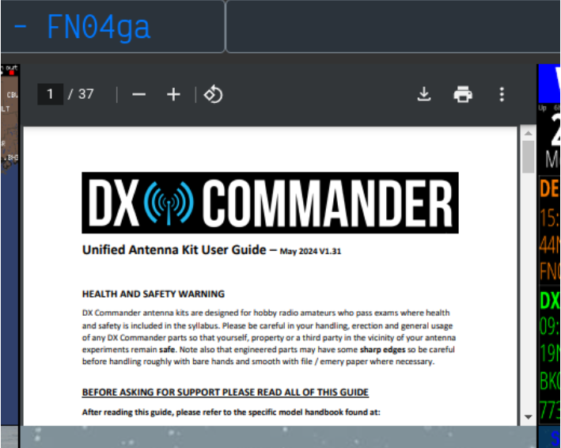

**"iframe|./PDF/2024-Unified-DX-COMMANDER-User-Guide131.pdf",**